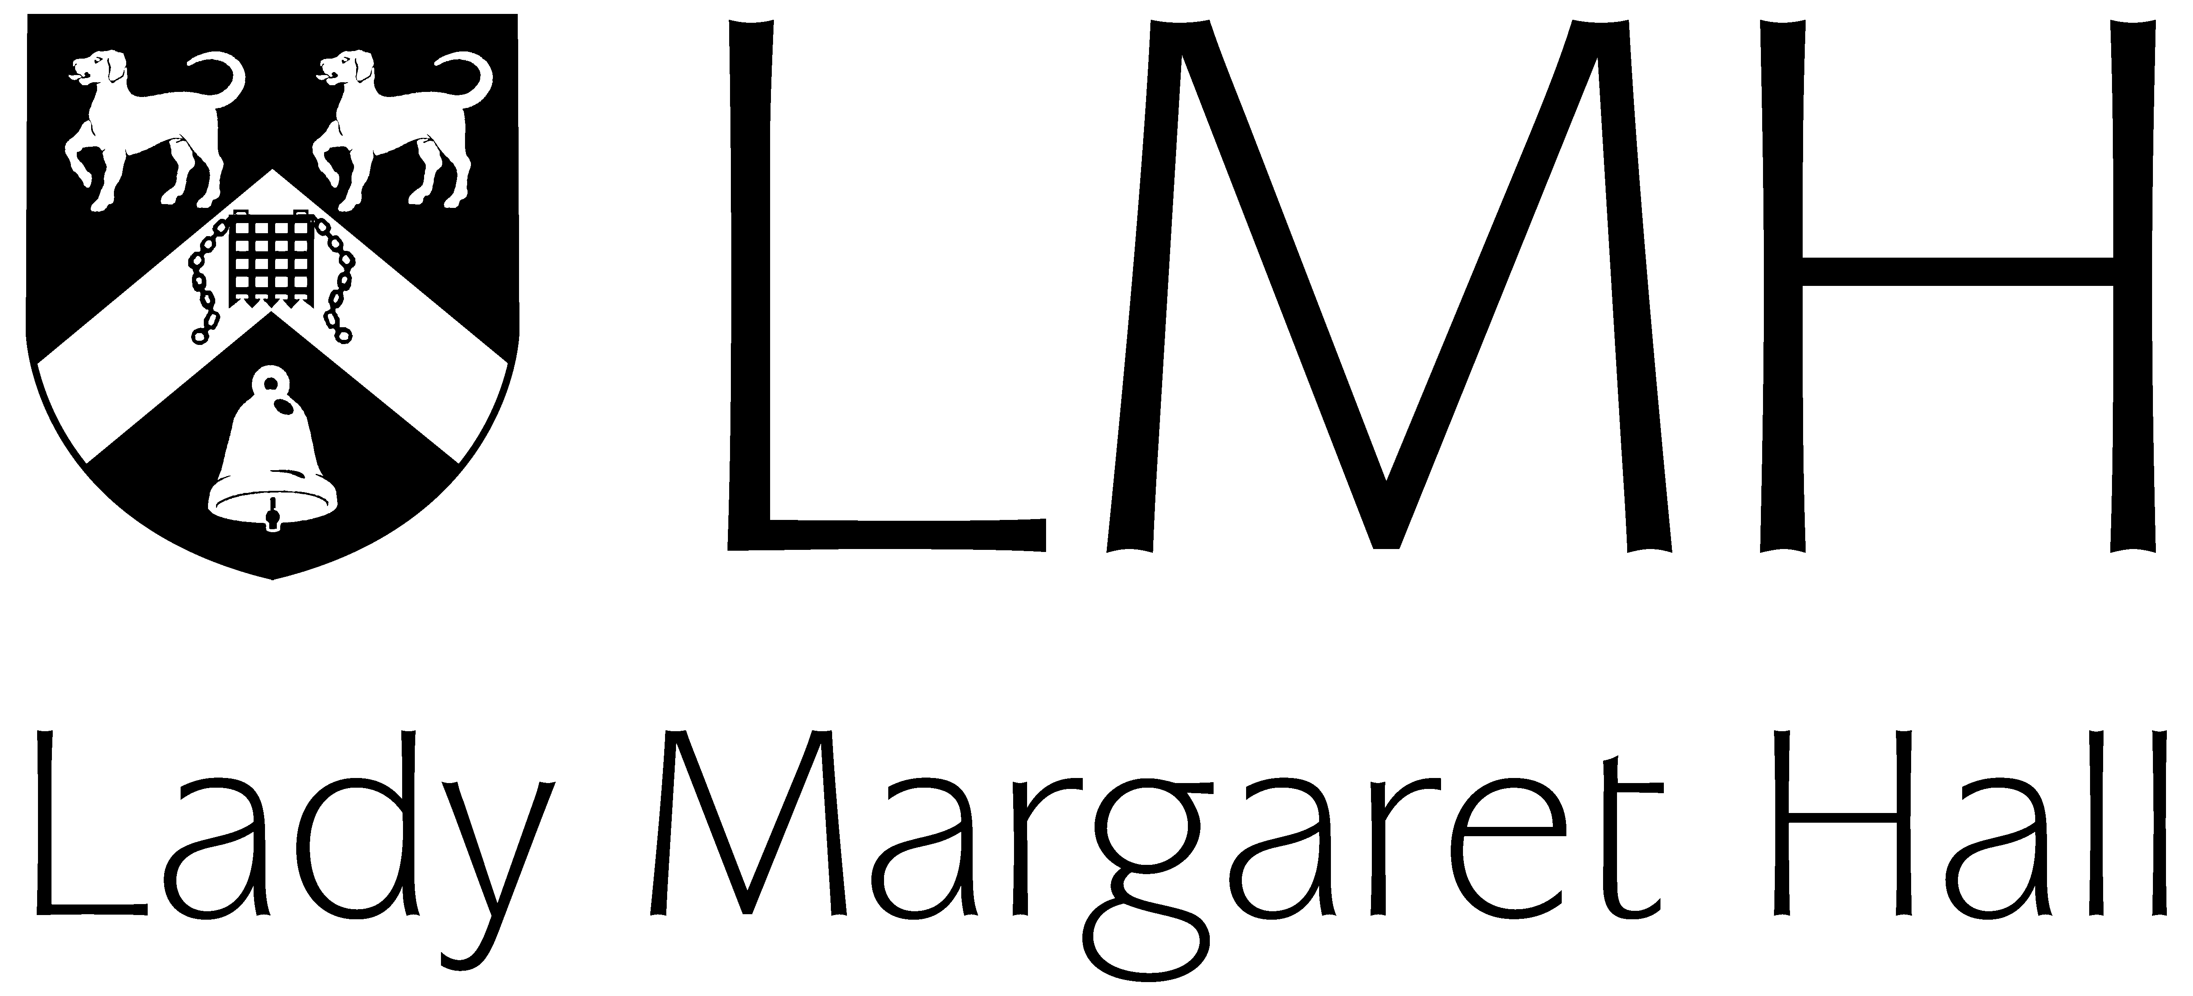 | LMH Summer Programmes Online  Application Form

Instructions

- Please complete this application form, taking care to answer every question.

- Send your completed application form and the required supporting documents to vacation.programmes@lmh.ox.ac.uk. This application form includes a checklist of the required supporting documents.

- Lady Margaret Hall will contact you to let you know whether your application has been successful, usually within two weeks. If you are accepted onto the programme, we will send an Enrolment Agreement for you to sign as well as instructions for the payment of your programme fee deposit.

- When your programme fee deposit has been received by Lady Margaret Hall we will contact you to let you know that your place on the programme is confirmed.

LMH will store your personal data in line with current data protection legislation and will contact you via email to process your application in relation to the LMH Summer Programmes. LMH will not share or distribute your personal data for other purposes than related to your application to and attendance at the LMH Summer Programmes.

Personal Details

Title: | Mr. | Mrs. | Miss | Ms. | Other:  _____

Full Name:
 | First name/Given name |  | Middle name(s) |  | Last name/Family name
Preferred Name: |  |  | Date of Birth (DD/MM/YYYY):
Nationality:

Home Address:

Telephone:

Please include the country calling code

What time zone will you be in during the programme?
Do you have any specific learning difficulties?

E.g. dyslexia, dyspraxia, ADHD
How did you hear about the LMH Summer Programmes?

Courses and Dates

Your LMH Summer Programme Online can consist of up to three programme sessions.

Each session lasts three weeks and you choose one course per session.

You may choose to join us for three weeks, or take part in multiple courses to create a programme lasting six or nine weeks.
Session One | 27th June 2022 – 15th July 2022
 | Diseases of the 21st Century – Infectious Diseases: Covid-19 and Tuberculosis
 | Artificial Intelligence and Machine Learning
 | Shakespeare in Context
 | Politics, Philosophy, and Economics: Globalisation, Populism, and Identity
 | I do not wish to join Session One
Session Two | 18th July 2022 – 5th August 2022
 | Diseases of the 21st Century – Metabolic Diseases: Diabetes, Atherosclerosis, and Obesity
 | Game Programming in Python
 | Shakespeare in Reception
 | Politics, Philosophy, and Economics: Ethics, Economics, and Politics of Climate Change
 | I do not wish to join Session Two
Session Three | 8th August 2022 – 26th August 2022
 | Diseases of the 21st Century – Cancer
 | Artificial Intelligence and Machine Learning
 | Shakespeare in Context
 | Politics, Philosophy, and Economics: Globalisation, Populism, and Identity
 | I do not wish to join Session Three

Academic Record

Name and address of your current university:
What stage of your studies will you have reached in Summer 2022?
Finished 1st Year
Finished 2nd Year
Finished 3rd Year
Graduated and preparing for postgraduate study

What subject(s) are you studying at university?

Please include major, minor, and elective courses.
What is your current GPA or equivalent?

Please provide your grades in the scale used at your home institution.
What is your level of English proficiency?
I am a native English speaker.
English is the language of instruction at my home institution.
Overall TOEFL score of 85 or above.
IELTS score of 6.5 (no less than 6.0 in each component).
CET-4 at 550 or above.
CET-6 at 520 or above.

Personal Statement

Please provide a personal statement. Your personal statement should tell us why you want to study on an LMH Summer Programme, what interests you about the course(s) you have chosen, what you hope to achieve on the programme, and why you think you think you would be a suitable candidate. Your personal statement must be between 500 and 750 words in length.

Personal Statement:

Supporting Documents Checklist

Please ensure you have answered every question on this application form.

Please send your completed application form to vacation.programmes@lmh.ox.ac.uk along with the following supporting documents:

- Academic Transcript

- Evidence of English language proficiency (if applicable)

Declaration and Signature

I confirm that the information I have given on this form is, to best of my knowledge, complete and accurate.
I understand that the information provided on this form will be held by Lady Margaret Hall for the purposes of student administration, subject to the provisions of the General Data Protection Regulation. (For further information on Lady Margaret Hall’s privacy and data protection policies, please see https://www.lmh.ox.ac.uk/about-lmh/further-information/privacy-and-data-protection.)

Signature: |  | Date:

