Art and Beauty
Lady Margaret Hall, 25th February 2018

All of us will have had some experiences of beauty, perhaps in the mountains, or a sunset over the ocean or just looking at a snowdrop-and of course in music. It’s an odd experience. There is something tantalising about it. We are drawn towards the beauty, almost wanting to become part of it, but it always eludes us. It’s not surprising therefore that since the time of Plato, human beings have wanted to attribute to it, along with Truth and Goodness, a kind of absolute status - it used to be called transcendental - and that people assumed almost without questioning that there is an integral relationship between art and beauty.
In the modern world, however, attitudes are very different. First, it is very widely assumed that all judgement of beauty is relative, and that beauty is in the eye of the beholder - a purely subjective matter. Secondly, the idea that art should express beauty is highly unfashionable, and closely connected to this, modern art has been characterised by very rapid changes of fashion, including the desire to create shock and sensation, with, at the moment conceptual art getting all the attention.
I imply no judgement about modern art, either for or against. I just want to begin, however, by setting where we are now in the context of tradition. As T.S.Eliot argued many years ago, unless you have a strong feel for tradition you will just be swallowed up by the fashion of the moment without knowing that you have, and without being able to evaluate it properly. The tradition from which modern art sprang - and by modern I basically mean from the Impressionists onwards, through Modernism, Cubism, etc. - suggests something very different from the nostrums of today. First, in the tradition beauty is not entirely subjective. It has certain definite characteristics. According to St Thomas Aquinas these are wholeness, harmony and radiance. Then, from a Christian point of view Beauty, again like truth and goodness, were not abstract nouns but had their origin in the being of God himself, the source and standard of all beauty. Until the Reformation it was integral to Christian thinking that beauty was as fundamental to God as truth and goodness. So, St Augustine, for example, addressed God as “O Thou beauty so ancient and so fresh”. This means that we come to God not just because it is right to do so, but because we are drawn, attracted, lured.
In the days of the Cold War, when I used to visit the Soviet Union, I met a young priest and asked him how it was that, being brought up as an atheist, he had become a Christian. He said first, that he had learnt about the faith through the books of anti-Christian propaganda because they contained quotations from Christian writers to refute them, but instead he had been drawn by them. Above all he had gone into Orthodox Churches and been captivated by the beauty of the icons and the singing - those spine-tingling Russian basses. So as an Orthodox has said, “We do not proselytise, we seduce”. Beauty seduces us and all beauty is finally rooted in the beauty of holiness of God himself.

It should be stressed that there is nothing sentimental about true beauty, and it is very different from the merely pretty or decorative. It can, and sometimes should, deal with what is shocking or which we might want to write off as unpleasing to the eye. It can only be produced by a fierce artistic integrity and the artist’s attempt to respond to the truth of things. This fierce integrity and this truth, combined with wholeness, harmony and radiance produces what the bible calls glory. It was this glory which Peter, James and John had revealed to them when Christ was transfigured, the story of tonight’s gospel. It was this glory about which Paul wrote in tonight’s epistle. For the God who said “Let there be light” has shone in our hearts to give the light of the knowledge of the glory of God in the face of Jesus Christ.”

There is no reason why modern art cannot reveal something of this glory, for everything that exists partakes of the glory of Being, simply by existing as itself. And a good artist can open our eyes in unexpected ways and indeed should be doing so, even if the subject matter or the method is unexpected or even jarring at first. Monet, Matisse, Chagall, Henry Moore, Stanley Spencer to name just a few, have changed the way we see things. They enabled us to see beauty in unexpected places or unfamiliar ways. But I would suggest that to be art rather than simply splodges of paint or polished rock or raucous sound, their work still contains characteristics of wholeness, harmony and radiance. As I said earlier, I make no judgements about modern art as a whole - it would be absurd to do so. What I have tried to suggest is that in thinking about it and viewing it, we do so aware of the whole tradition of Western art from the Greeks onward, so that we can see it in perspective and learn to make discriminating judgements.

Within that tradition a huge number of works are on Christian themes. Here there is a difference of emphasis between West and East. In the West, Christian art has been seen as a way of teaching people about the faith. In the East it has been seen as more than this. There Christian art, the Icons, make present to us the spiritual reality they depict and draw us into that reality. That’s why the Orthodox, and increasingly in the modern world, Western Christians as well, pray before Icons. I will end by focussing on just one icon, that depicted on the cover of the service sheet.

The great centre of Christian art for 1200 years was Constantinople, today’s Istanbul. However, as the Christian faith spread northwards, that tradition went with it and became centred on a number of cities in Russia. And early in the 15th century, at a very low point in the country’s history, when it was devastated by Mongol invasions, Andrei Rublev painted this sublime icon.

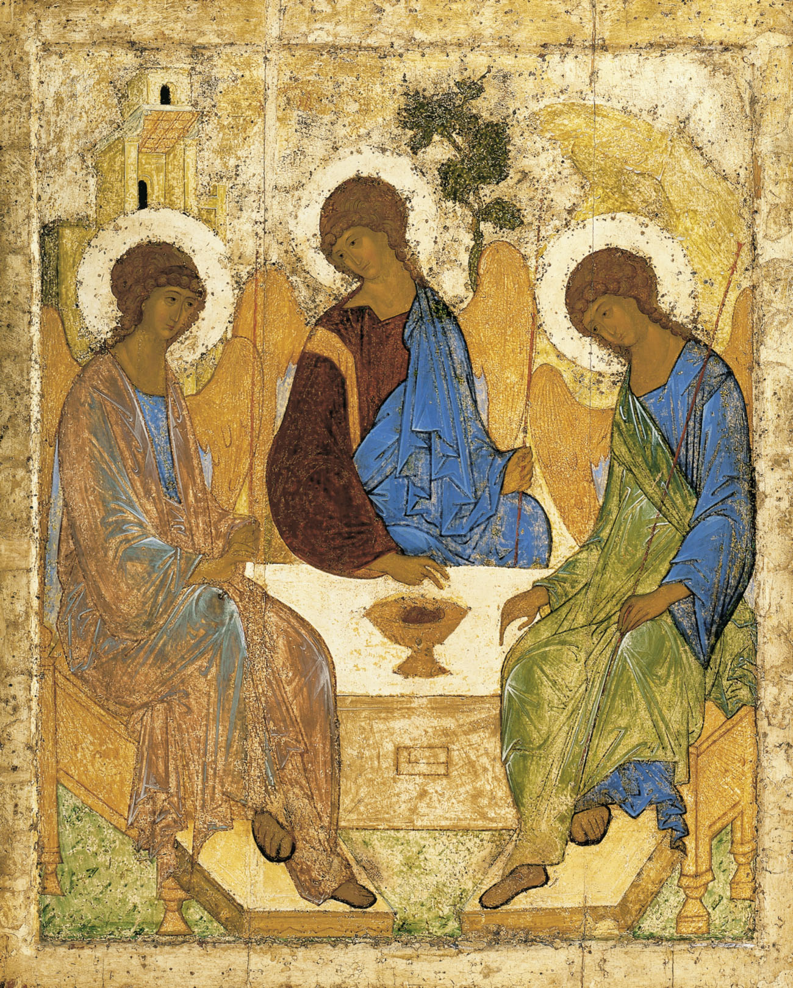
It is based on the story read this evening, of Abraham offering hospitality to three strangers - and is sometimes called The Hospitality of Abraham. The three strangers turn out to be angels, and from an early age, this has been taken as a sign of God as Holy Trinity. In the early depictions of the scene, for example in the 6th century church of San Vitale in Ravenna, Abraham and Sarah are included in the scene, but Rubliev has focussed entirely on the three angels. You will see in the icon that the flowing robes and elegant lines of the angels stand directly in the line of Greek art from the 5th century before Christ. You will notice the wonderful harmony in the posture of the angels and the inclination of their heads, forming a circle of unified love. Then, what is most striking - the viewer seems to be invited into this heavenly banquet, into the very life of God. Beauty draws the eye in, the empty place stands ready and words of a George Herbert poem come to mind 'You must sit down,' says Love, 'and taste my meat.'. This is the Divine banquet of which every Eucharist is a fore-taste, and here this evening we are drawn again, enticed and invited in to share in the very life of God, who came amongst us that he might dwell in us, live in us and work through us.

Richard Harries is a former Bishop of Oxford. His latest book is The Beauty and the Horror:searching for God in a suffering world. SPCK

Summa Theoogica ,1a,XXXIX.8 For beauty includes three conditions, integritas sive perfectio (integrity or wholeness), debita proportio sive consonantia (right proportion or harmony) and claritas (radiance)

